**Assignment Brief – BTEC**

|  |  |  |  |  |  |
| --- | --- | --- | --- | --- | --- |
| **Programme** | | Level 3 Extended Diploma in Creative Media Production (Games Development) | | | |
| **Unit number(s) and title covered** | | Unit 4: Creative Media Production Management Project | | | |
| **Assignment number & title** | | Assignment One: Product Concept | | | |
| **Student name** | | *Lewis Hawkins* | | | |
| **Assessor** | | James Shaun | **Internal Verifier** | *David Matravers* | |
| **Date issued** | | *04/03/2019* | **Submission deadline** | *15/03/2019 at* ***4.30pm*** | |
| **Assessment Criteria** | **To achieve the criteria, the evidence must show that the student is able to:** | | | | **Assessor confirm met** |
| P1 | Originate, develop and research an idea for a media product working within appropriate conventions and with some assistance | | | |  |
| M1 | Originate, develop and research an idea for a media product showing some imagination and with only occasional assistance | | | |  |
| D1 | Originate, develop and research an idea for a media product showing creativity and flair and working independently to professional expectations | | | |  |

|  |  |  |  |  |  |  |  |  |  |
| --- | --- | --- | --- | --- | --- | --- | --- | --- | --- |
| **Assessor feedback - 1st submission** | | | | | | | | | |
| *Task No* | *Targeted Criteria* | *Met* | *Comment* | | | | | | |
| 1 | P1 |  |  | | | | | | |
| 1 | M1 |  |
| 1 | D1 |  |
| **Did the learner meet the original deadline or agreed extension?** | | | | Yes ☐ No ☐ | | | | | |
| **Assessor signature** | | |  | | | | **Date** | |  |
| **Resubmission authorised?** | | | | Yes ☐ No ☐ | | | | | |
| **New agreed deadline date for submission** *\* must be within 10 days of receiving original assignment back* | | | |  | | | | | |
| **Lead Internal Verifier signature** | | |  | | | **Date** | |  | |
| **Assessor feedback - Resubmission** | | | | | | | | | |
|  | | | | | | | | | |
| **Assessor signature** (resubmission only) | | |  | | **Date** | | | |  |

|  |  |  |  |  |
| --- | --- | --- | --- | --- |
| **Scenario** | | | | |
| After months of developing projects, interning, and working for an array of small time developers including “Onslaught Games”, “PCPlayer” and “Insane EnterThainment” you have decided to branch out and start your own developer house.  You will have to navigate the difficulties in having creative freedom, working as a team and deciding on the scope of a new creative digital product of your own design. You must conceptualise, pitch for investment and then develop this new product right here in the sunny south west.  Your first steps should be documenting who you will be working with and the conceptualisation of a new original media product. It must be a media product, but it can be from any media section including film, television, audio, games development, animation and website development. | | | | |
| **Tasks and criteria covered** | | | | |
| **Task 1**  You must conceptualise and plan an original creative media product. This must be an original product that could be potentially marketed and is either a computer game, film short, TV pilot (short), website, music, or magazine.  Your plans for this product must take the form of a proposal document or portfolio which fully outlines a clear idea for a project with a clearly defined target audience.  You should document any team meetings that take place, and the outcomes/agreements set from those meetings. You must research effectively the audience and the concept to ensure it is fit for purpose, and that you can successfully navigate any possible potential legal or ethical issues. This planning process must also include visual mock ups and concepts including, moodboards, mind maps, storyboards, concept art and any other issues such as constraints.  You must take care to ensure every member of the group contributes to the overall final plans, and may wish to include the following in the final submission:   * Project Concept and Audience * Mindmaps/Moodboards/concepts * Justification of idea * Legal/Ethical and Moral issues * Constraints * Research evidence (Audience and Market) * Review of research and how it fits your audience.   [Task Covers P1, M1, D1] | | | | |
| **Evidence you must produce for this task** | | | | |
| Report  Supporting Images | | | | |
| **Sources of information** | | | | |
| **Sources of information**  **Textbooks**  Baylis P, Freedman A, Procter N et al – BTEC Level 3 National Creative Media Production, Student Book  (Pearson, 2010) ISBN 978-1846906725  Baylis P, Freedman A, Procter N et al – BTEC Level 3 National Creative Media Production, Teaching Resource  Pack (Pearson, 2010) ISBN 978-1846907371  Chandler H – The Game Production Handbook (Charles River Media, 2006) ISBN 978-1934015407  DiZazzo R – Corporate Media Production, 2nd Edition (Focal Press, 2003) ISBN 978-0240805146  England E and Finney A – Managing Multimedia: Project Management for Web and Convergent Media, Book 1:  People and Processes, 3rd Edition (Addison Wesley, 2001) ISBN 978-0201728989  England E and Finney A – Managing Multimedia: Project Management for Web and Convergent Media, Book 2:  Technical Issues, 3rd Edition (Addison Wesley, 2001) ISBN 978-0321436931  Fraser P and Oram B – Teaching Digital Video Production (BFI Education, 2005) ISBN 978-0851709772  Hardy P – Filming on a Microbudget (Pocket Essentials, 2004) ISBN 978-1842433010  Kindem G and Musburger R – Introduction to Media Production: From Analog to Digital, 2nd Edition (Focal  Press, 2001) ISBN 978-0240804088  Laycock R – Audio Techniques for Television Production (Focal Press, 2006) ISBN 978-0240516462  Maciuba-Koppel D – The Web Writer’s Guide (Focal Press, 2002) ISBN 978-0240804811  Nisbett A – The Sound Studio: Audio Techniques for Radio, Television, Film and Recording, 7th Edition (Focal  Press, 2003) ISBN 978-0240519111  Oriebar J – Digital Television Production: A Handbook (Hodder Arnold, 2001) ISBN 978-0340763230  Roberts-Breslin J – Making Media: Foundations of Sound and Image Production (Focal Press, 2003)  ISBN 978-0240805023  Rudin R and Ibbotson T – An Introduction to Journalism: Essential Techniques and Background Knowledge (Focal  Press, 2003) ISBN 978-0240516349  **Websites**  https://trello.com/en **-** A Project Management and Workflow assistant  www.gamasutra.com – A sister publication to the print magazine Game Developer  www.skillset.org/interactive/careers/article_4754_1.asp – Skillset’s pages on the role of a project manager | | | | |
| **Student checklist** | | | | **Complete?** |
| Proofread work | | | |  |
| Reference / Bibliography (if applicable) | | | |  |
| All pages attached and numbered – including introduction/conclusion/front sheet | | | |  |
| **Authenticity of Evidence Student declaration** | | | | |
| I certify that the evidence submitted for this assignment is my own.  I have clearly referenced any sources used in the work.  I understand that false declaration of authenticity (i.e. plagiarised work) is a form of academic misconduct and the relevant College procedures will be instigated if I am found to be in contravention of these. | | | | |
| **Student signature** |  | **Date of submission** | 15/03/19 | |
| **Re-authentication of Evidence Student declaration (for resubmission only)** | | | | |
| **Student signature** |  | **Date of resubmission** |  | |

NB. Students – the assignment starts on the first page **after** these front sheets, i.e. Page 1.

* For your convenience, page numbers have been inserted into the footer. **Please keep them**.
* You may choose to add a contents table (ToC) in this section.
* Please **do** **not use text boxes** for the main body of your written answers.
* Please make sure that images/screenshots are correctly formatted, laid out and labelled. A table of Figures (ToF) may also be added if you wish.
* Make sure you use Page (or Section) Breaks whenever a new page is required. (Rather than adding large numbers of Return/Paragraph characters.) Ensure that new Section breaks continue with correct orientation and correct page numbers.
* Ensure that you have referenced your work throughout, using references in text and that you also have a reference list and full bibliography at the end of the work according to the current **Harvard Referencing** conventions. **Failure to do so will make your work more difficult to authenticate.**

**Task One:**

**Project Concept & Story Summary:**

This game is an RPG – FPS looter-shooter which aims to engage the player into a mindset of exploration and immersion. The games story will be told through a standard campaign which will give context to the events of the game, while also progressing deeper into the lore.

It features a short Campaign to get the player interested in the story, while also providing an introduction to the game’s mechanics. Side activities include assignments which are structured similar to a campaign mission but behaves like a bounty or recovery mission, instead of setting up the story.

The game also features free roam on the planets used in the campaign. These locations have “Hidden Quests”, which are solved by deciphering riddles and solving puzzles. The hidden quests are not displayed in a menu or other traditional way, instead items are picked-up in the world which can be inspected to go give clues on the next step.

Throughout the campaign the player will be interacting with three major individuals, Marcus Cortsmith, Sargent Kavac, and themselves, each with their own ideas on how to deal with the current situation.

**Marcus Cortsmith:**

Marcus Cortsmith is obsessed with a mysterious Crystal he found on Pluto. These crystals were recently found underground and seem to hold vast amounts of an unknown energy. They were used to power the seven exo-suits split between the player and other special forces soldiers, however Marcus’ is a bit different, this one is way more powerful.

Marcus found it in a pit full of others which were all just as weak as the one the player uses, this led him to research it. After discovering ancient underground buildings on Earth, Mars, Venus, and Pluto he concludes that Humans were once a powerful species but were wiped out by an unknown war with another race. This is backed up by a discovery that suggests the crystals are biological in nature and are around 400,000 years old, the same as the buildings.

At first, he thinks the crystals were created by some kind of weapon, but as the story progresses the crust of Venus is opened in search of an unknown energy source. This turns out to be due to a hibernating robotic army. These robots are also carbon dated to around 400,000 years old and despite being hostile to the player, evidence of them being created by humans to fight an unknown alien race is found within the bunkers they’re hiding in.

**The Player:**

The player is a British special forces soldier, who has been chosen along with 6 others to test a prototype exo-suit. Although the player does his job, there’s always an itch to understand what’s going on. He meets Marcus through a mysterious message after passing the first mission, although strange the players urge to understand leads him to trust Marcus.

Together they find more and more evidence to suggest that humans were once a powerful species but were wiped out by another race. The discovery of the Chosen (another alien race on mars) confirms some of their most dreaded theories.

At first Marcus believed the invasion was part of a joint attack by the Akktanes and Chosen in an effort to steal some crystals, however that becomes less and less likely as the conflict between the two becomes more apparent.

The Chosen are spotted trying to communicate with an unknown entity, which is cause for worry between Marcus and Kavac. Despite their difference in opinion, Kavac and Marcus work together to decipher the message. What is discovered forever changed Kavacs approach to this war.

The chosen were communicating with a ship somewhere far outside of this solar system using a wormhole just past Pluto. They called whoever owns this ship a Creator, but this wasn’t a simple conversation, it was a negotiation. They were asking if they could leave the system, saying they’ve done their part.

This confirmed Marcus’ final theory in which he hypothesised something, perhaps whatever destroyed humanity 400,000 years ago, was herding them towards this system to start a war, which they would finish.

Now the player no longer needs to play both sides and can work towards a solution to a problem that could be the final extinction event.

**Sargent Kavac:**

Sargent Kavac is close to the player despite being in charge of his unit. He thinks the best way to fight this war is to gain territory and reach out to any other community of survivors that are discovered. In short, he wants to play it safe. His plan is going well until the danger seems to be larger that first anticipated, which is only amplified to pure fear once the Chosen’s message is decrypted.

Despite never having an interest in the conspiracy theories Marcus presents, he does understand that a few extra outposts, walls, and soldiers aren’t going to solve this issue, and that terrifies him. The player is tasked with finding out where the Creators are so sets off to mars to find out, while Sargent Kavac readies the ships for battle.

Once the player finds the location of a Creator’s base on Pluto Sargent Kavac tells the player of a ground to orbit cannon in the Pacific Ocean. Currently this is controlled by Akktanes and is preventing all large ship launches. The player is stationed on an aircraft carrier being escorted by 3 destroyers and is tasked with taking over the base.

Once the ground to orbit cannon is liberated the player along with 50 soldiers with 5 tanks are sent to Pluto to destroy the Creators base. This will be the most difficult mission the player has to complete and will require more than just a few smart ideas.

When arriving at Pluto they war with the chosen who have already set-up shop there. Once braking through their lines of defence the player with 3 other soldiers enter the base and discover chosen bodies everywhere. Something’s not right, there’s no bodies of whatever they’re fighting, they killed them all without one casualty.

This leads the player to a circular room with 5 cryo-pods and a holographic map in the center. The map is showing the solar system, with red warning circles on Earth, Venus and Pluto. These are all ships that failed to launch.

Four of the cryo-pods are dark, without light, but one is still occupied. Approaching this caused the pod to open, clouds of steam cover the area around it. The steam fades and the Creator gets out slowly revealing itself to be 8 feet tall and bipedal. It’s presence in the room causes a soothing hum, as energy being emitted from its body react with the metallic walls.

This creature attacks the player with full force, creating energy beams with its hands, and using other powerful abilities. Health regeneration and being able to pull the player in and out of pocket dimensions make this the hardest fight in the game.

The map expands to cover 15 solar systems with a massive ship lying dormant on the boundary. This ship flashes green before beginning to move towards Earth. Although the campaign ends here the player has many side activities and free roam events to participate in, that contain more information on the story.

**Target Audience:**

My target audience for this game will be 16 – 30-year olds who enjoy spending countless hours in a single game. If one item is prioritised it would be fairly quick to get, but due to this game’s strong enthesis on collecting, many days will be required to get full sets of gear.

My target audience likes a challenge, so although having some slow-paced activities, most will be very difficult and require the player to think outside the box to outsmart the enemies.

Bosses will also be a large part of this game; my target audience enjoy bosses for their loot and the fight.

The last aspect is mysteries. My target audience is all about having to solve puzzles and riddles. However these are optional and not required to complete the game, in other words, they’re mostly used to unlock doors to a stash of loot.

**Mindmaps, Moodboards, Concepts:**

This moodboard is for environments on the plants. My idea for most is to have a barren surface, but plants and animals under the crust.

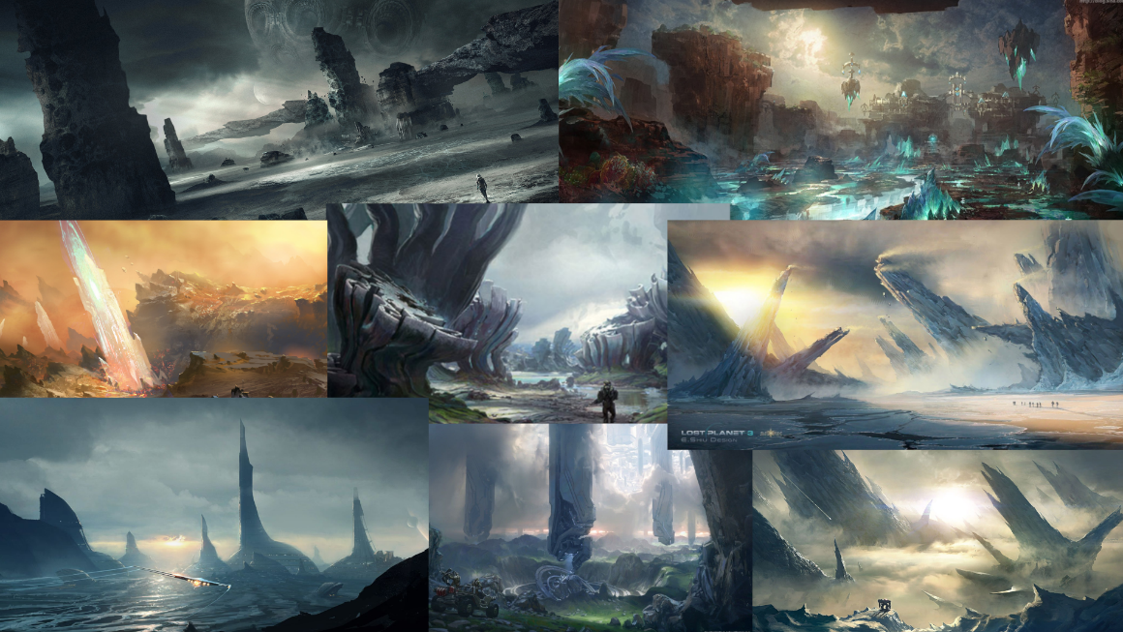

This is a concept for one of the enemies. This is an Akktane foot soldier which is fast and hard to kill, but its low armour makes every on target shot hard hitting.

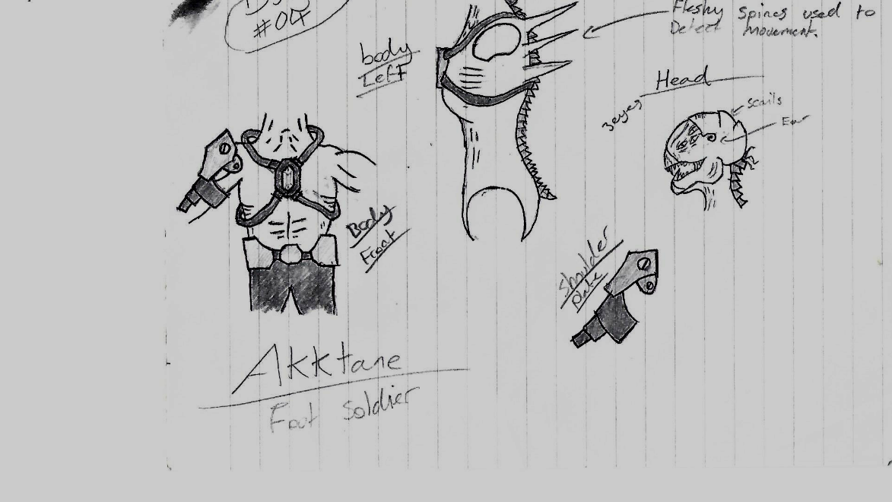

This set of armour is for the player. It’s the default set the player gets at the start of the game.

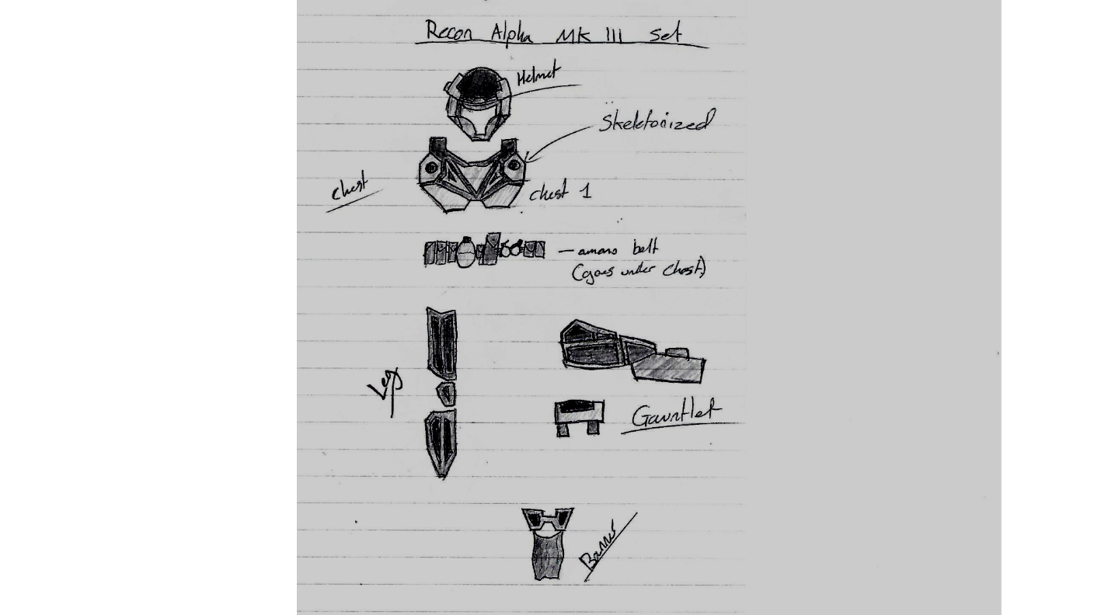

This mindmap is a quick list of basic features.

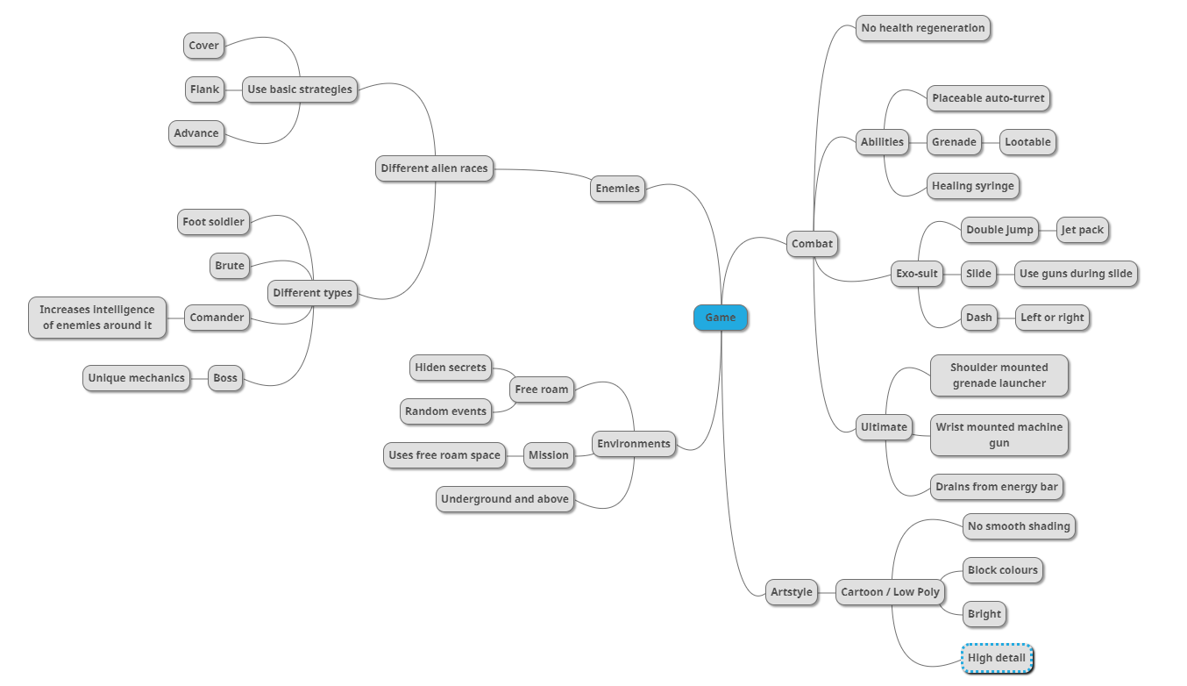

**Justification of Idea:**

Although this is a large game the prototype will only consist of the basic features listed in the mindmap. This will be easy to complete within the time constraints if I spend my time wisely and don’t overdo anything.

Despite having a large checklist, most points can be completed within a day, sometimes in a few hours. The player controller, AI, and inventory, make-up about 75% of all the work.

**Legal / Ethical / Moral issues:**

Legal: This game will need to be created without the use of copyrighted work. This will be easy enough if I make sure to drastically alter any inspiration I take from other games. For example, in the mindmap all images are not my own, therefore if I want to use it I’ll have to change most of the parts, to make it unique.

Ethical / Moral: It’s easy for things to be taken out of context and be presented as controversial or offensive, so I should be kept in mind that this game resembles real-world issues as little as possible. That way even if one slips through the cracks it would be harder to come to the wrong conclusion.

This game will not use any offensive language therefore I don’t need to worry about how that would be handled.

**Constraints:**

The number one constraint is time. This is a large project, but as said in “Justification of Idea” only creating what I need will drastically lower the time needed. The removal of all activities and environments will reduce time needed by at least 80%, however to avoid the alpha being to repetitive it will feature a prototype horde mode, and environment. Enough to showcase all features.

Since this is a looter-shooter there will need to be a lot of weapons and armour to collect, preferably in the hundreds. Although I will be able to reskin most of the items, I will need to cut back on the number of items in the game.

Another constraint is the content I put into the game. I will need to make sure it can run at least around 50 FPS, at medium settings. To achieve this, I will need to make sure all 3D models I create are within a reasonable polygon count and reduce the texture resolution to as low as possible.

I will also have to add a settings menu to allow players to disable post-possessing such as motion blur and bloom. This will allow player to get the maximum performance if they don’t mind lowering graphical settings.

**Survey Results:**

In an RPG / FPS hybrid, which genre would you like to see prioritised?

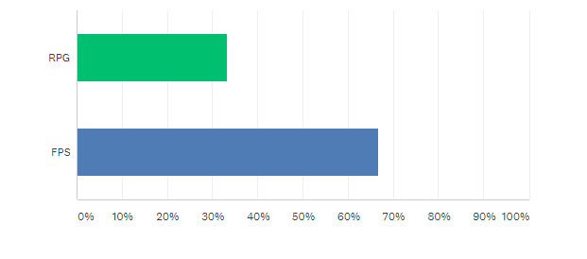

Would you prefer a longer campaign, or more side activities?

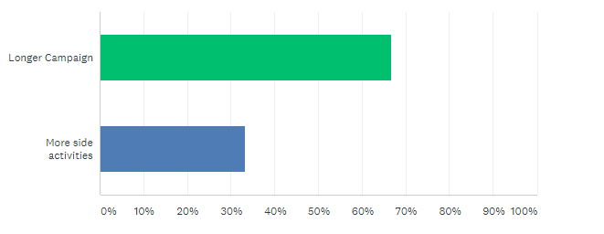

Would you prefer bosses to be more common or rarer and have unique abilities?

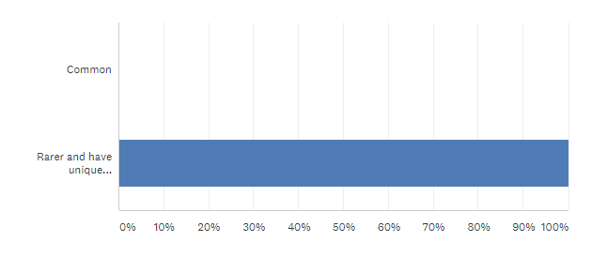

**Survey Review:**

In the first question the audience was asked if they preferred for FPS or RPG aspects to be prioritised and they responded with more FPS, but since there was still a following for RPG I will still add more than the minimum for that.

In the second question the audience was asked if they prefer a longer campaign or more side activities and they said they would prefer a longer campaign. This has allowed me to decide to add a few more missions instead of side activities, but I will also make the side activities more story orientated to allow for them to be enjoyed by the majority.

The final question askes if bosses should be common or rarer and have unique abilities. 100% of the votes were for the second option so there’s no question what route I will take for this area.

Overall this survey has allowed me to decide on a few aspects of the game I previously was torn on.

These results fit my audience perfectly because it allows me to create a more hardcore and replayable experience for the players.